Introduction
The non-exam assessment (NEA) counts towards 20% of the A-level qualification. The most important skill that will be assessed through the NEA is your ability to create a programmed solution to a problem or investigation. This is recognised by allocating 42 of the 75 available marks to the technical solution (the actual code) and a lower proportion of marks for supporting documentation to reflect the expectation that reporting of the problem, its analysis, the design of solution or plan of an investigation and testing and evaluation will be concise.
The importance of the end users/third party
Top marks always come from those pupils that are constantly checking in with the people that are going to be using their final product. For example, this can be your mates who are going to play your game. Throughout this documentation you will see references to the important stages where end user feedback MUST be sought and documented. The highest marks come from those pupils who show how this is informing their project from initial ideas, through design, development and evaluation.
Selecting a project
You can choose between:
Solution to a problem or an idea of something you want to create.
Examples of this type of project include:
- a simulation, e.g. of a business or scientific nature, or a well-known problem such as Conway's Game of Life (see https://en.wikipedia.org/wiki/Conway%27s_Game_of_Life)
- a solution to data processing problem for a business, e.g. stock control, membership systems
- the solution of an optimisation problem, e.g. production of a rota, shortest-path problems, route finding
- a computer game with a dynamically created maze
- an application of artificial intelligence
- a control system, operated using a device such as an Arduino board
- a website with dynamic content, driven by a database back-end o an app for a mobile phone or tablet to remotely control a server.
Investigation
You can select an area of the subject that you are interested in and investigate this area beyond the A level course, with the focus being on programming. For an investigation you will need a supervisor with some knowledge of the area being investigated. We can help to find someone for you.
Examples of this type of project include:
- machine learning algorithms
- 3D graphics rendering
- analysis of live data feeds, e.g. Twitter feeds
- investigation into the use of neural networks, e.g. as a noughts and crosses player
- exploring large datasets for correlations, e.g. the World Bank’s datasets (see http://data.worldbank.org), and creating useful visualisations of these correlations to answer interesting questions o scientific investigations, e.g. where an analytic solution is not possible.

Marks
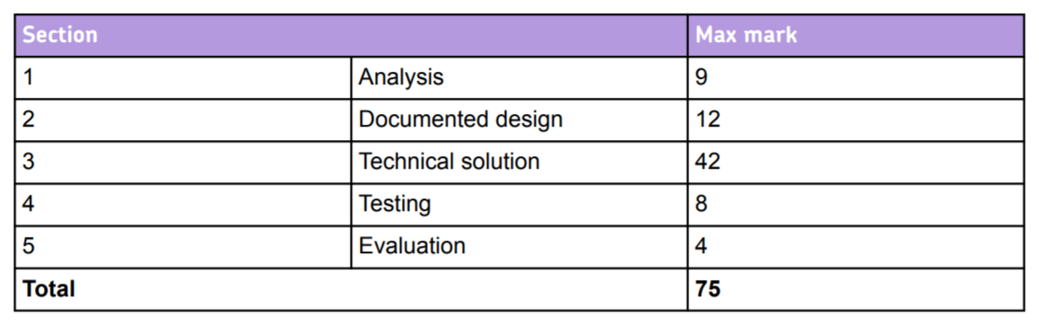

The next section is an overview of the paperwork you need to produce. The words in red are the titles and subtitles of each section. They MUST be in your paperwork – even though they may be empty for some time.

The NEA
1 Analysis
Analysis enables you to gain a deep understanding of your problem/investigation. This in turn allows you to identify the objectives for the project, giving a clear purpose and direction for your design and solution development.
Each of the following headers are required sections for your Analysis section:

1.1 The project identification and background
This should be a clear statement that describes the project, investigation or problem area. It should include detail on of how the project ideas were researched.
Identifying a third party: It will be useful if a third party (that is someone other than the you) is involved in the analysis process. The third party might be a potential end-user of the software, such as a friend, relative, employee or teacher or somebody with knowledge, interest or expertise in the area. Their role is to support you in investigating the problem, deciding upon the objectives and to give feedback, particularly at the end of the project. For an investigative project, the third party is most likely to be the person who has agreed to act as your supervisor.
The background should be in sufficient detail for the examiner to understand the problem being solved/investigated.
You may want to include similar systems, solutions, games, etc., that have helped you to decide on exactly what you are going to make. You can discuss at this point the positive and negatives of these and what you are going to take forward into your final product. You may include screen shots of these.
There are likely to be areas that you may not cover within the scope of your project. Although it is important that your system will meet the needs of your user, you should list any anticipated limitations of your system. These are likely to cover the amount of data that your system can cope with and extra features that may be added later. Indicate any constraints that the user has, such as software, hardware, time, user knowledge, and so on.
1.2 Objectives
This is by far the most important part of the entire project. These will inform everything that you do. They may change slightly over time as your project progresses, but without clear objectives you will struggle. You will use your objectives in two ways. One way is to check that you are meeting the objectives when you are designing/creating the project. The other is at the end of the project when you carry out your evaluation. You will use these objectives to help you to evaluate the final program. For these reasons, you must both quantify and qualify your objectives.
To assess whether you are doing this well, imagine giving your objectives to someone else and asking the question “could they make exactly my project by meeting these objectives?”.
To quantify means talking about actual numbers, for example: ‘the database must be able to hold 10,000 records’, or ‘the system must be able to convert a graphic in under a minute’. To qualify means describing something by listing its characteristics or qualities. A qualifying statement can usually be checked in some way, for example ‘the user must find it easy to work through the process in three steps’.
These are a subset of the objectives from a quiz based on puzzles:
3. In order to help the user if they are unable to answer the question, a puzzle must be shown below the question.
3.1 The answer must be calculated based on the randomly generated question and displayed on a grid of 16 squares.
3.2 The first 15 of the aforementioned squares must be saved as JPEG images and the 16th should be replaced with an empty square.
3.3 The order of the 16 squares must then be randomised and presented to the user, below the exam question.
3.4 If it is next to an empty square, the user must be able to move a tile by clicking on it.
3.5 The user must be able to submit an answer, even if the puzzle has not been solved.
These must be in numbered bullet points.
Remember, objectives should be:
- Specific: objectives should specify exactly what they want to achieve.
- Measurable: it should be possible to measure whether the objectives are met or not.
- Achievable: the objectives should be achievable.
- Realistic: the objectives should be realistically achieved with the resources available.
- Timed: there should be a set time given to achieve the objectives.

1.3 Research (which must include a summary table)
This section will describe how the problem was researched. This will contain several subsections.
1.3.1 Interviews/Surveys
You need to show evidence of how you have worked with your end user or third party to come up with your set of objectives. This could include a short discussion on the results of one-to-one interviews with people on ideas for your project. It could be the results of a survey. It could be feedback from prototypes or initial design ideas. DO NOT include the full transcript of conversations – just the summary.
Extract example:
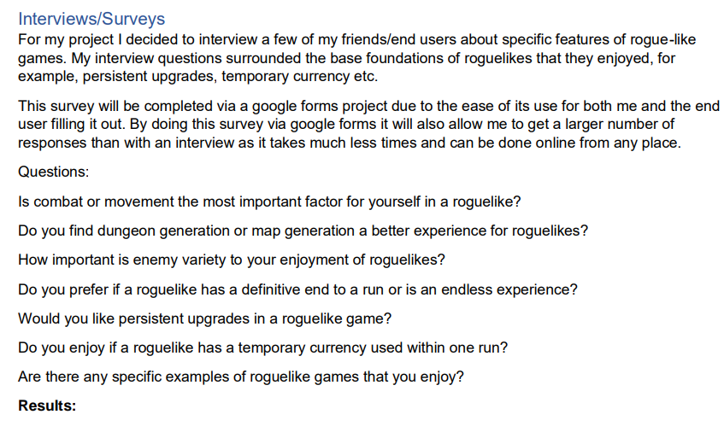
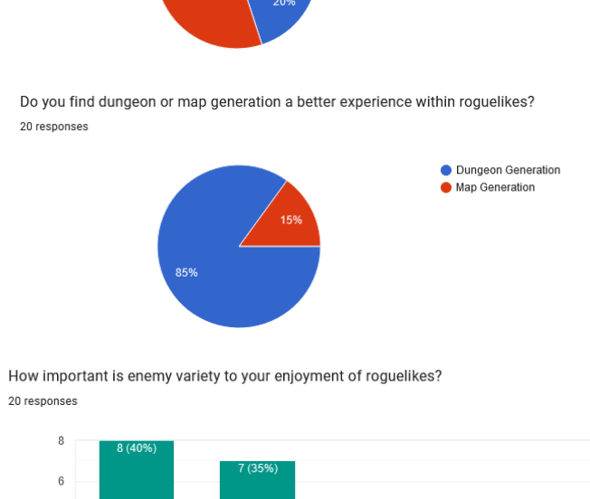

1.3.2 Technical/Skills research
This section should contain any technical/skills research you have done to help inform your objectives for your end solution. If you are creating a game, it could be research into similar games with you discussing what you like and want to include or what you don’t want to have. If you were planning to work with an API then you would include all your research into the API here. You may use websites to help you, but make sure you fully reference them (with the date accessed) and acknowledge this.
Extract example:
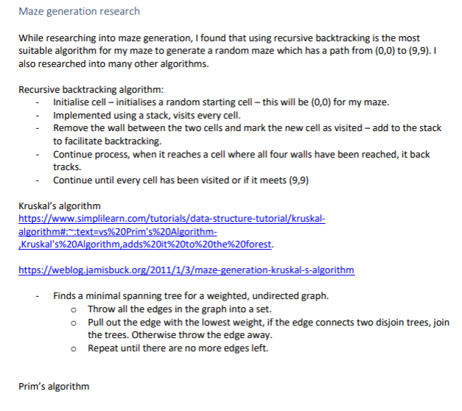
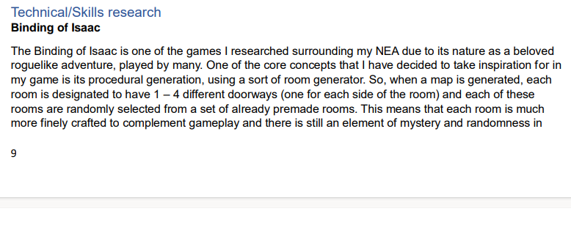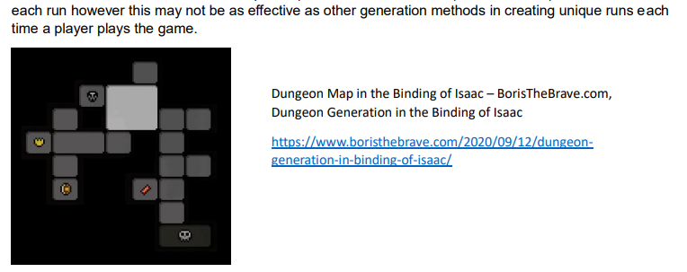

1.3.3 Research Table
You need to include a table that shows a summary of the research that you have completed to formalise your objectives. This is not just technical research but end user research (interviews, survey’s etc). It can also be observing similar systems.
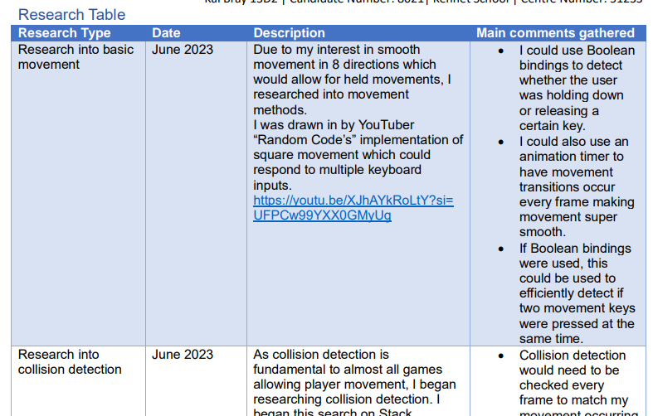
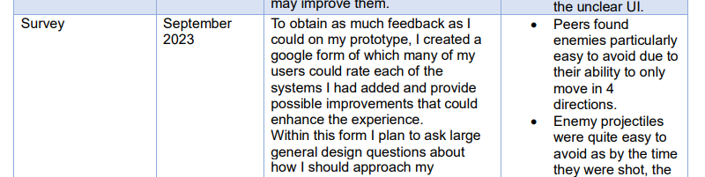
1.4 Prototypes
You can include any initial prototyping that you have done to help inform the direction of your final project. This can also be prototypes that you have shared with your end user to help discussion on the final objectives of the project. For example, you may have a prototype of a certain screen that they say they don’t like, give you feedback on improvement and then you have a final agreement that is reflected in your objectives. This is when you have two or more options and you are trying to finalise which one to use.

1.5 Justification of chosen solution (this will link back to your research)
Based on all the research you have completed; this section will explain how you are going to complete this project. Your justification should include the software/hardware you will be using to implement the solution. Explain why you have chosen your programming language/package. Here you can explain why and how you are going to use a database. It could explain why you are going to work with an existing piece of hardware or software. It could describe an API you are going to use or why or a particular software library.
1.6 Initial Modelling
This finally section summaries any initial ideas on data structures, algorithmic solutions, data processing, data flow, sketches of proposed outputs, sketches of game play, etc. For this section you may have all the red headers or just some of them.
1.6.1 Story Board
If you are creating a game then your analysis must also include a story board to explain the outline function of the game. This is to help your end user/third party to understand the flow of the game.

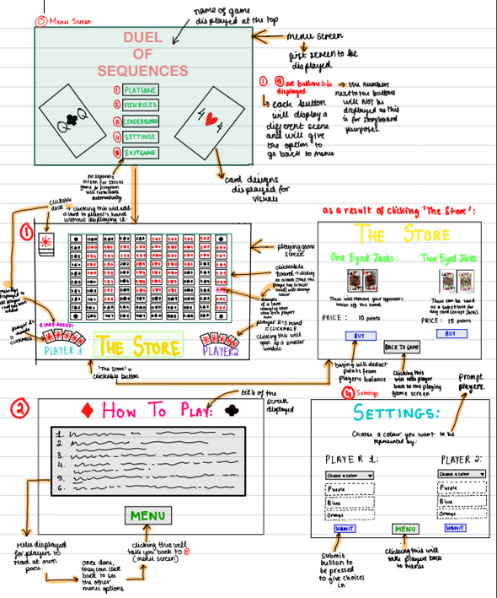

1.6.2 Database Modelling
Entity–relationship (E-R) model and diagrams – if using a database
If your project is going to store data in a database you will need to provide an entity–relationship model.
Term | Explanation
Entity | An entity is an object, person, event or thing of interest to an organisation and about which data are recorded.
Relationship | A relationship is an association or link between two entities.
Degree of relationship | The degree of relationship between two entities refers to the number of entity occurrences of one entity that are associated with just one entity occurrence of the other, and vice versa.

You need to draw a diagram of the entities in your system. Next, you need to identify the relationships between the entities – one-to-one, one-to-many, many-to-many.

1.6.3 Identification of objects and object–analysis diagrams
What are your initial ideas on the classes you are going to need.
Object analysis consists of determining the objects, determining the relationships between the objects and determining the attributes and the behaviours of each object.
You will need to provide a diagram that shows the objects, their associations, aggregations and inheritance.
For example, in a game you might decide you need bad character and a good character objects. You identify the common attributes and behaviours that you are going to add to a parent class and then two new classes for the ‘bad’ and ‘good’ that will inherit from the parent class. You can then include the differences for these two child classes.
1.6.4 Sketches and process flow of proposed output
This section allows you to organise your ideas on how your project will flow and deal with inputs, outputs and processing. You can use flow charts here or any method you like to show your thought process. You might for example show what happens when a button is pressed. Does it trigger and algorithm, pull something from a database, open up another screen, etc.
1.6.5 Data flow diagrams (DFDs) (see Mrs Poyda/Zamani to check)
If you are dealing with large data sets, your diagram needs to show where data comes into the system, how it is processed, where it is output from the system, and where data is stored in the system. Remember to use the correct DFD symbols. You need to provide a DFD for both the current system and the proposed system. The current system may be a manual system and this still applies. The DFD for the proposed system is likely to differ from the DFD for the current system, and if so should also be drawn up.
This section could also contain any other modelling of the problem that will inform the Design stage, for example a graph / network model of Facebook connections, state diagrams, scientific / mathematical models or formulae.

1.7 Analysis Data Dictionary
The analysis data dictionary is the place to keep any descriptions/definitions of terms that the end user/third party has specified. A dictionary should be created that contains an entry for every item of data that is to feature in the proposed system. Data dictionaries do not contain any actual data, only the information about how it will be stored. Therefore you should outline:
- the entities or variables in the proposed system (that relate to user input/output)
- the fields that will be stored in each entity and what form the information takes, including data types and maximum and minimum values
- a description added to each entry that makes clear the purpose of the data item, its type and range of permitted values
This must be in a table.
If your project is not going to have data contained in a database, you still need to define the fields of data you are going to use on input and output. The data dictionary should contain enough information for a user interface designer to work with this information to produce a user interface that could be shown to the end user. You should also include error messages and other display items.
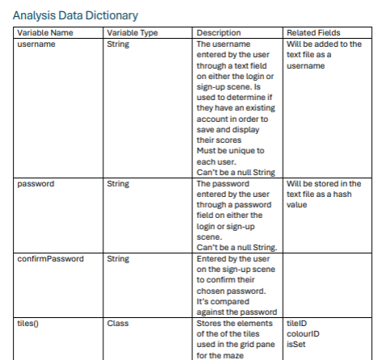

2 Design
Evidence for this section of the project can be produced before, after or during the coding of the system.
Each of the following headers are required sections for your Design section:
2.1 Design Introduction
This is the opening section to this document and should be a clear overview of each part of project and how it will all fit together. This will be a high-level overview of them main modules of your project. How data structures are to be implemented. How you will use/used a database (if appropriate), etc. Make sure this is not a repeat of your analysis introduction – it should clearly reference code, classes, etc and the relationships between them.
2.2 Hierarchy chart
A hierarchy chart illustrates the relationships between the modules in the system. It does not tell you what tasks are to be performed within a module. It does not tell you when or how a module executes; it identifies which modules exist and which modules call which other modules. They help the programmer in dividing a software problem into parts that are small enough to be understood. Programmers do not write programs as one long series of steps, they break the programming problem down into reasonable units, called modules and tackle one task at a time. If a subroutine or function is useful and well written, you may want to use it more than once within a program. A good policy is to place statements that perform one specific task together.
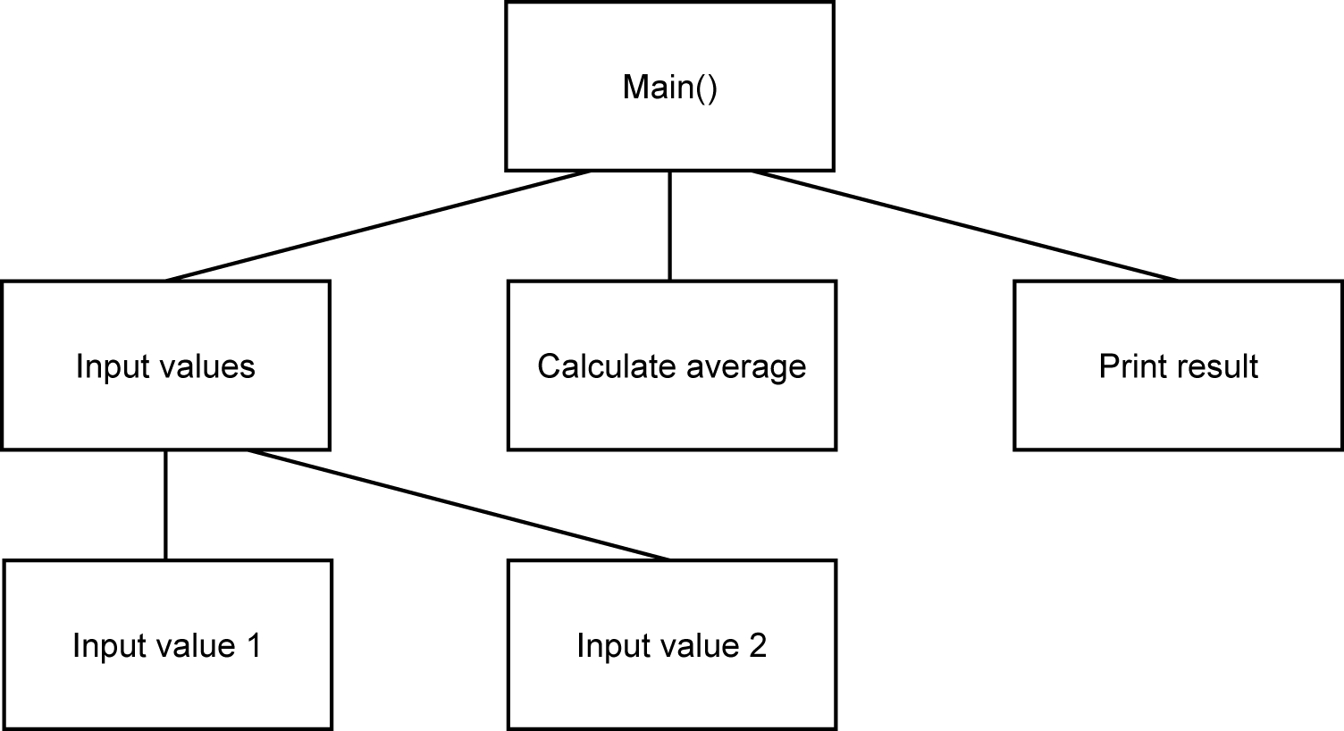
The hierarchy chart for a number-averaging program shows which modules call which others.
Or you could have a:

2.3 Structure chart
A structure chart is a hierarchy chart with interfaces and control information. It does not tell you what tasks are to be performed within a module. During the actual building of the program the chart is continually referred to. Often, it is modified as programmers learn new details about the program. After a program is completed, the structure chart is used to fix bugs and make changes (maintenance). It is especially important in this stage, because often the original programmer may be gone, and a programmer new to the project uses the chart as a navigational tool into the source code files.
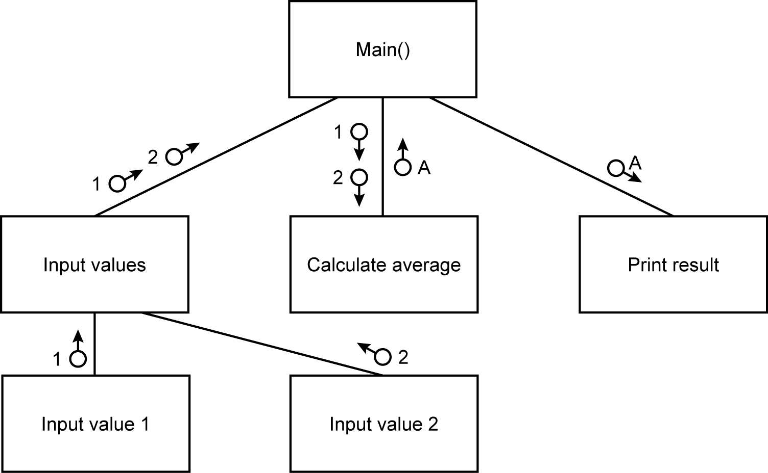
The structure chart for a number-averaging program shows how the data is imported and exported from each module.

2.4 Complex Code - Nonstandard Algorithms/Sections of Key code with title
Technical skills, pseudo code, solution to individual problems /SQL/Data structures to support explanation)
This is the most important section of Design. What we expect to see here is individual sub headers for each project challenge that you had. This could be, for example, creating gravity or dealing with collisions. This section can be completed before, during and after your code is complete and should provide evidence of the sophistication of your project. It can contain all the code you needed to complete each task and should also include data structure decisions and solutions, SQL, etc. Please remember to include lots of examples of output as well.
Importantly the exam board is looking at how your ideas developed. What worked and what didn’t. You can show code /pseudocode ideas that were not good enough and talk about what you needed to do to improve them. Here is also a good place to link in research that you did and link it to your final solution. Basically, your journey but it is NOT A DIARY!
I would suggest you do at least 3 of your algorithms in pseudo code. The best ones to do are those that required quite complex algorithmic solutions. This will help the examiner to understand your solution without trying to get their head around the code.
If you are using some advanced technical skills for your project (for example networks, APIs, etc.) You must include evidence for this as well.
Extract examples:
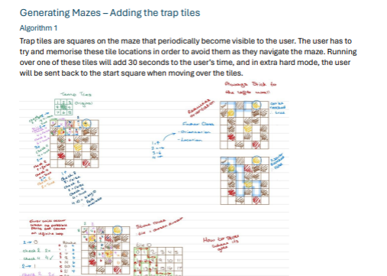
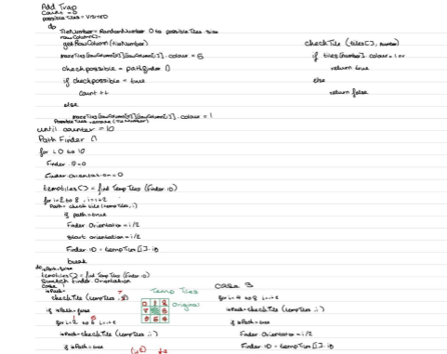
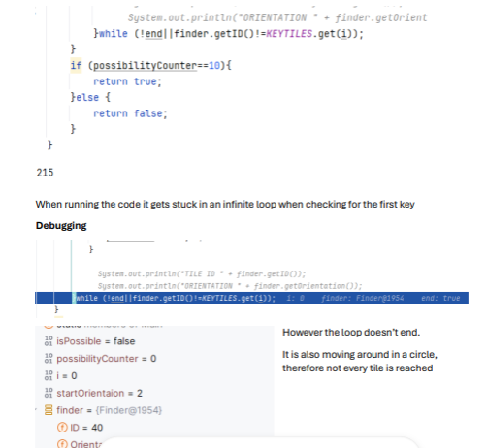
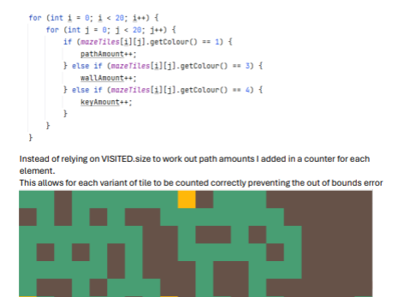

Hand Drawn diagrams to support evidence:
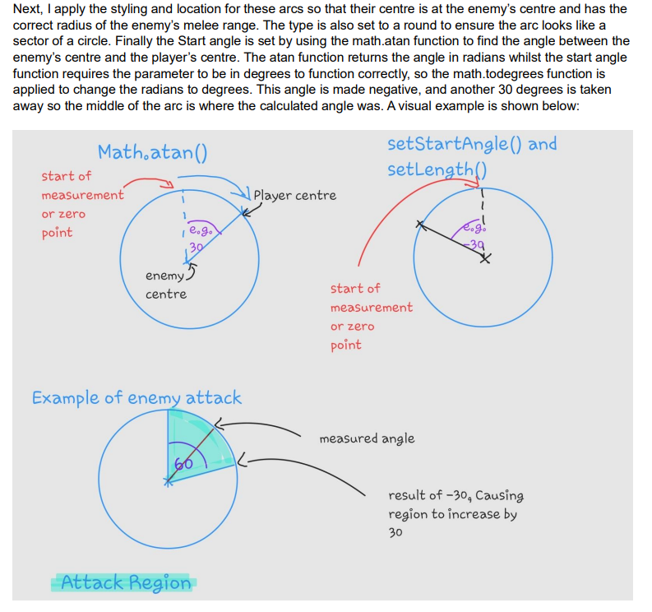
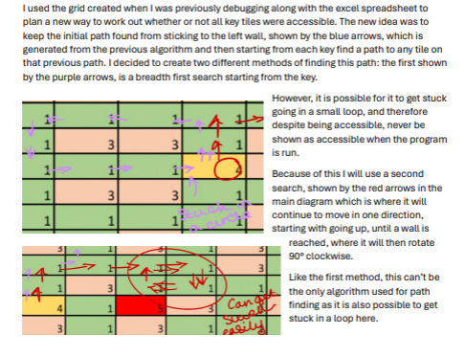

2.5 Object diagrams and class definitions
Class diagrams show the classes of the system, their interrelationships (including inheritance, aggregation, and association), and the methods and attributes of the classes.
Classes are depicted as boxes with three sections, the top one indicates the name of the class, the middle one lists the attributes and fields of the class which it has inherited, and the third one lists the attributes and methods that are additional to the class. This can automatically be reproduced from IntelliJ, so check with a teacher before you spend hours hand doing them!
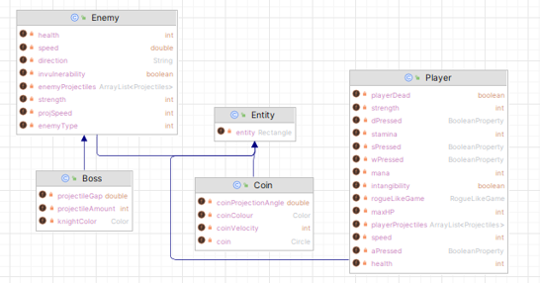
2.6 Prototyping (if appropriate but not compulsory)
A prototype is a simplified working model of part of your system. It is an ideal means of communicating with the end user to check that the design meets the user’s needs. Show the prototype to the user and discuss issues of design. For example, the user may suggest that terminology used in the interface is not what the user is accustomed to, or that not enough/too much space is allocated to a data entry. Maybe a menu option is missing.
You are ok to add even more prototyping at this point and, if necessary, include end user feedback.
2.7 Design data dictionary and data structures
Use the analysis data dictionary and add entries for variables you need for processing purposes. Decide on data types for all data items; this could include data structures such as arrays or records. Add validation rules with reasons why they are required and what they are testing. How are the values to be stored while the program is running and what data need to be stored long-term? Are data to be stored in database tables or files?
This must be presented in a table.
2.8 File organisation – if applicable
Files stored on magnetic disk can be organised in a number of ways. There are advantages and disadvantages to each type of file organisation, and the method chosen will depend on several factors such as:
- how the file is to be used
- how many records are processed each time the file is updated
- whether individual records need to be quickly accessible.
The available methods include:
- serial
- sequential
- indexed sequential
- random.
Choose between simple text files, CSV files or typed files.
If data is stored in arrays while the program is running, but needs to be stored long-term, then serial or sequential file organisation should be considered.
If the program is to access data records held on disk as and when required, then a random access file organisation might be more appropriate.
2.9 E-R model and diagrams, and normalised database tables – if appropriate
During the analysis phase you drew a diagram of the entities in your system. The relationships between the entities were identified – one-to-one, one-to-many, many-to-many. In order to implement the system, many-to-many relationships need to be resolved into one-to-many relationships using link entities. Use the entity descriptions identified to organise the attributes into tables so they are fully normalised. This should include screen shots of the tables you have created.
Annotation to help support the database design is very helpful.
2.10 Human–Computer-interface design
User interface design should include input/output, forms and reports. The user will be faced with an initial interface screen, possibly with menus, help and input screens. This section can be the screen shots of your final screens/output or the original sketches. This should comply with anything you have said in your analysis about screen design. You should give good reasons why you have designed the screens in the way you have.
Your aim is to produce good HCI design that prevents errors occurring and minimises the amount a user has to remember.
Points you should consider when designing your screens:
- Users’ needs and usability.
- Input/output devices.
- Colour; do not use it unnecessarily; use dark colours on a light background or vice versa.
- Have headings so the user knows where he/she is in the system.
- Include instructions on the screen where necessary, including reference to help and manuals.
- Indicate where the user is to enter data.
- Indicate the format of the data.
- List error messages, feedback and dialogue boxes, and make sure they are user friendly.
- Avoid clutter on screens and reports.
- On-line help.
- Shortcuts.
- Consider icon usage and presentation.
- Exits should be clearly marked.
- Consistency in your design.
2.11 System security and integrity of data
If a student has decided to encrypt data in a database or when transmitting data between a client and server you would expect this to be discussed in the design section. It also might be appropriate for a student to recognise the need for deleting related data when a user is deleted to keep referential integrity. These sorts of considerations tend to surface more in sophisticated systems where a student also has a good understanding as to issues such as security and integrity of data.

Finally, add anything else that you think is relevant and important to your project – this section is all about showing your level of skill in completing this project.

